Day in the Life of the Hudson River 10/13/22
Valentino Pier, Red Hook, Brooklyn
RIVER MILE: -2.3
Salt Front: ~ RM76
The Brookyln New School– Barbara Taragan
50 students & 10 adults
Latitude 40.6788656 N & Longitude – 74.01831 W
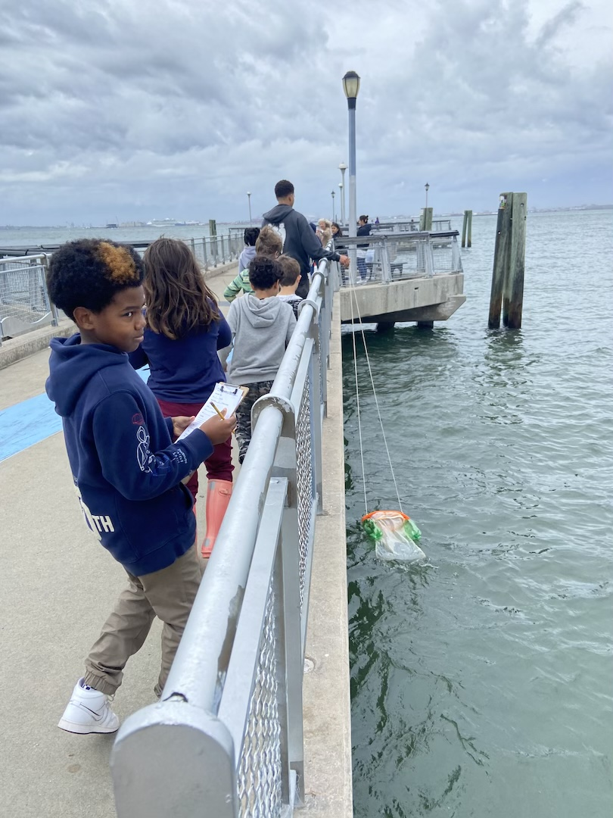 | 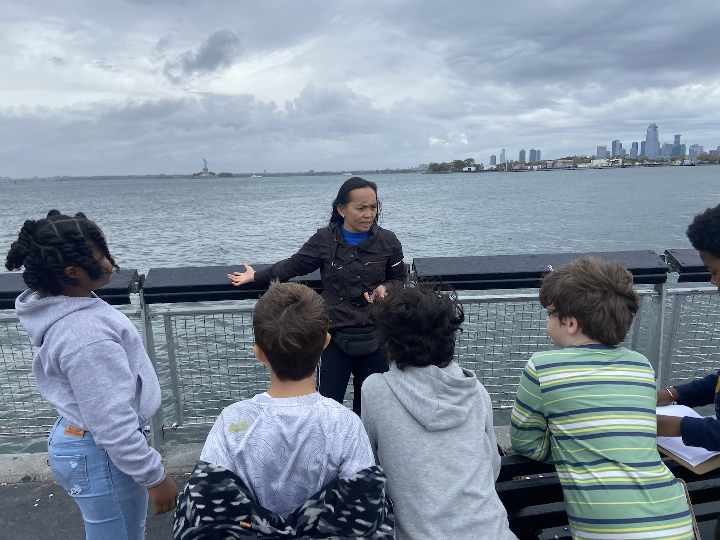 | 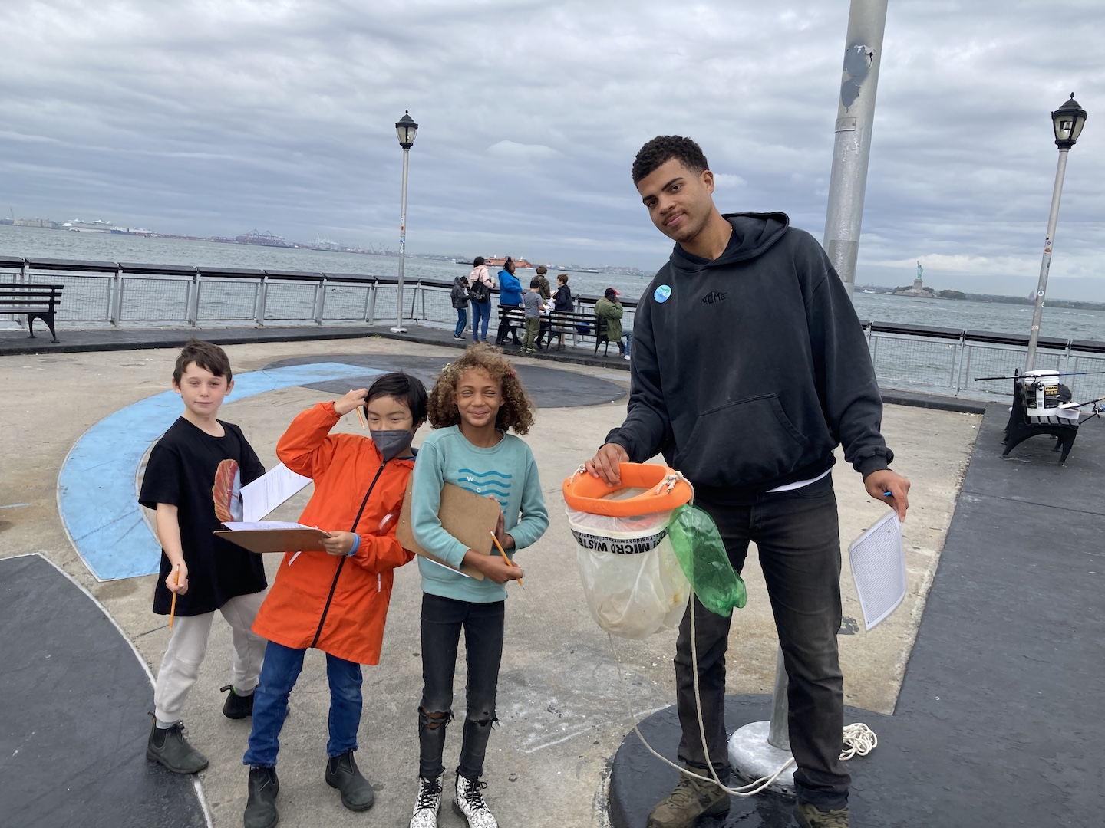 | 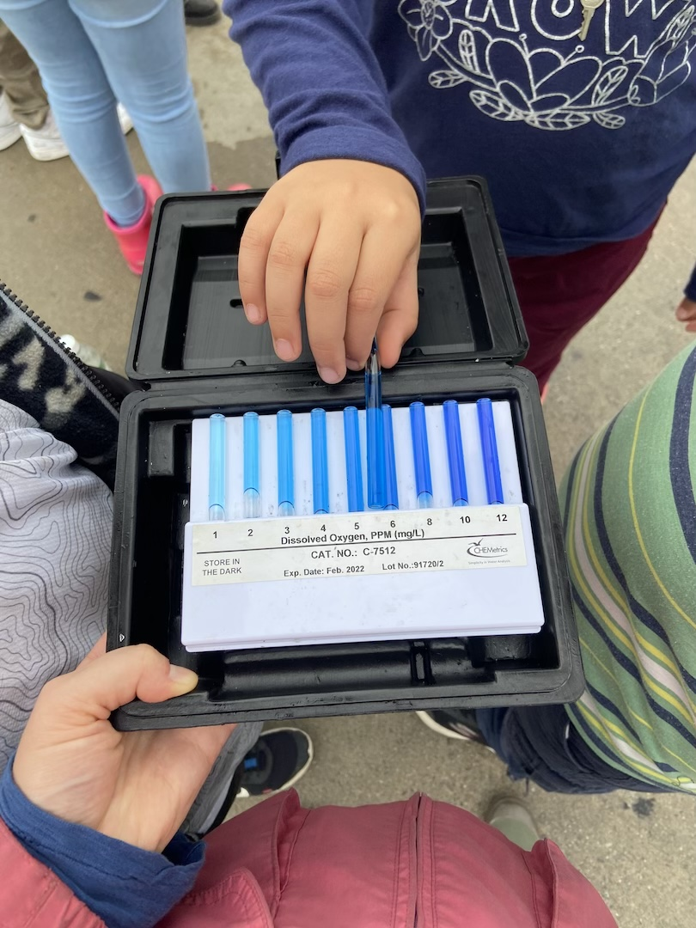

Location: Valentino Pier, Red Hook, Brooklyn, NY
Area: A large pier of rocks with a small rocky beach; large pier
Surrounding Land Use: 75% Industrial/Commercial; 10% Urban/Residential; 5% Beach; 10% Landscaped area with seagrasses.
Sampling Site: Recreational pier and beach. Lots of fishing at the end of the pier.
Shoreline: Riprap
River Bottom: Sandy and rocky near the little beach area
*NR = Not read/recorded
ITEM |  | Time |  | Reading |  |  |  | Comments
Physical
Air Temperature- NR
Wind Speed: NR |  |  |  | Anemometer |  |  | Beaufort | Direction
Weather today |  | 10:00 AM |  | >75% cloud cover |  |  | Drizzle for a few minutes
Weather the past 3 days: |  | NR
Tides- NR |  | Time |  | Rising, Falling, Unchanged |  |  | Water Height (cm)
Current- NR |  | Time |  | Cm/sec |  | Knots | North/South | Ebb/Flood/Still
Water Temperature- |  | 11:00 AM |  | 16°C |  |  | 62°F
Turbidity- Long Sight Tube (120 cm) |  | 11:00 AM |  | 80 cm
Chemical
Salinity-Hydrometer |  | 11:00 AM |  | 24 ppt
Standardized Salinity – Refractometer |  | 10:00 AM |  | 26,000 ppm
DO – Chemets Kit |  | Time  11:00 AM |  | Temp  16°C |  |  | ppm DO  6 to 8 ppm | % saturation  NR
pH – Lamotte Wide Range Kit |  | 11:00 AM |  | 7
Nitrates- NR
Phosphates- NR
Alkalinity- NR
Biological-
Fish – Oyster Cage |  | Number |  | Name |  |  | Length of longest | Length of smallest
10:00 AM |  | 2 |  | Tautog (Blackfish)
Fish Totals |  | TOTAL: 2 |  | Diversity: 1 |  |  |  | *also large tautog caught by fisherman
Macroinvertebrates |  | Number |  | Name |  |  | Length of longest | Length of smallest
Macroinvertebrate Totals |  | TOTAL: 0 |  | Diversity:0 |  |  |  | *Mud crabs and mussels found in the oyster cages
Sediment Core - N/A
Length | H2S smell |  | Oxid Top |  | Oil |  | Grain Size | Other Features
NR
Boats-NR
 | Time |  | Name |  | Color |  | North/Southbound | Light/Loaded
Commercial NR
Recreational NR

